Fall Prediction - PCC

Presented to: | ThriveWell Tech / Martha Gurzick and team
Version Number: | Final
Revised Date: | 02-06-2025

Table of Contents
1 Overview 3
1.1 Project Overview 3
1.2 Asbury Communities 3
2 Project Requirements 3
3 Data Sources 4
4 ETL Process Design 4
4.1 Extraction 4
4.2 Transformation 4
4.3 Loading 4
5 Technical Details 4
5.1 Tables 4
5.2 Models 5
5.3 Features 5
6 Workflow and Scheduling 6
7 Testing and Validation 6
8 Dashboard View 7
9 Appendices 8

1 Overview
We have developed a dual-model architecture, enriched by data analysis, designed to predict the fall risk level of active residents by incorporating multiple predictive factors. Our primary objective is to empower healthcare providers, such as nurses and medical experts, with real-time insights to enable timely interventions and prevent potential falls.
The model classifies residents into three distinct risk categories: high, moderate, and low, providing real-time updates to ensure proactive measures can be taken. To make these predictions actionable and user-friendly, we have integrated an interactive dashboard. This dashboard offers intuitive features such as filtering, selection, and customization, allowing users to analyze data effortlessly.
The system also provides straightforward, human-readable explanations for each prediction, enabling caregivers to understand the underlying factors that contributed to the risk classification.

1.1 Project Overview
Overview
Project Name | Fall Prediction- PCC
Project Description | Dual-model architecture, designed to predict the fall risk level of active residents by incorporating multiple predictive factors.
Project Start Date | February 2024
Stake Holders | Nick Patel, Woody Pryor
Additional Notes (Add as required)

1.2 Asbury Communities
The following are the communities for which we are making predictions:

Asbury Communities
Asbury Solomons | SNF
Asbury Methodist Village | SNF
Bethany Village | SNF
Springhill | SNF
Normandie Ridge | SNF
Riverwoods | SNF

2 Project Requirements
This section provides detailed business and technical requirements for delivering this project.

Business Requirements:

Implement preventive interventions to reduce and eliminate the occurrence of falls in Skilled Nursing Facilities (SNF).

Technical Requirements:

- Cloud Platform: Amazon Web Services (AWS)
- Data Integration: AWS Glue
- Data Warehousing: Amazon Redshift
- Programming Language: Python (including relevant data processing libraries)

3 Data Sources
Below are the data sources for this project.
- Data Sources - Point Click Care (PCC)
- Format – Raw/source data
- Location – Redshift DWH

4 ETL Process Design

4.1 Extraction
- Source Systems: Source systems used for this project is Point Click Care (PCC)
- Data Extraction Methods: Required data tables are extracted from Redshift using an AWS glue script

4.2 Transformation
- Data Cleaning: AWS Glue used for data cleaning, preprocessing, model training and prediction generation.
- Data Transformation Rules: Used Scikit-learn, Pandas and NumPy to make transformations on the raw data.

4.3 Loading
- Target Systems: Quick Sight Dashboard
- Loading Methods: AWS Glue, SQL

5 Technical Details

5.1 Tables

Cluster: acm_dwh_cluster
Tables:
- inc_note
- inc_incident
- inc_std_pick_list_item
- diagnosis
- diagnosis_codes
- facility
- mpi
- clients
- medications_test
- bed
- census_codes
- cr_alert
- as_assessment
- as_std_assessment
- as_std_question
- as_std_pick_list_item
- as_response

5.2 Models
Implemented a dual-model approach, one excluding past fall incidents and another incorporating them.
- Random Forest - makes predictions for residents without a history of fall.
- XGBoost - makes predictions for residents with a history of fall.

5.3 Features
Key risk factors identified through literature review and exploratory data analysis included age, body mass index (BMI), use of assistive devices, medication regimens, diagnostic histories, and recorded fall incidents. We integrated these variables into a robust dataset. subsequently used for model training and validation.
- BMI
- Fall Prone Medication Categories
- Fall Prone Medications
- Fall Prone Diagnoses
- Age
- Gender
- Monthly Fall Count
- Quarterly Fall Count
- Assistive Device
- Compound Risk Score - weighted combination of age ranges and history of fall.
- Target

6 Workflow and Scheduling

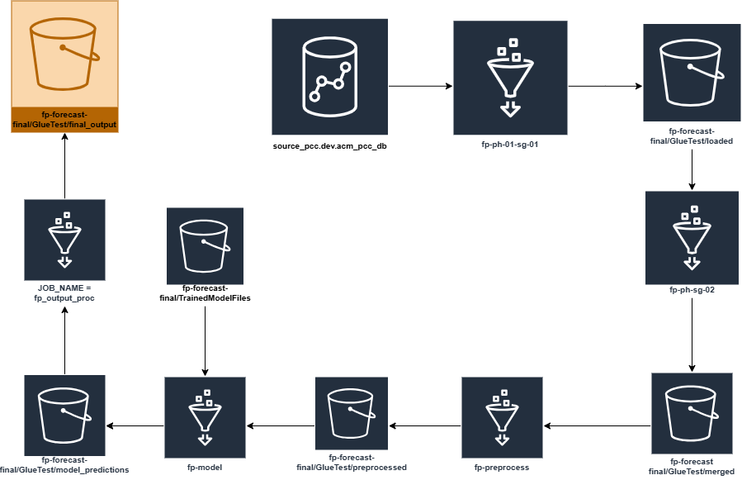

7 Testing and Validation
- Staff utilized a dashboard interface (e.g., Amazon QuickSight) to view each resident’s Risk Score on a daily basis.
- Clinical notes and incident reports were continuously logged, ensuring that predicted high-risk events could be compared against actual outcomes in near-real time.

8 Dashboard

Dashboard View
https://us-east-1.quicksight.aws.amazon.com/sn/account/asbury-twt/dashboards/b0819017-1c6d-4b13-b7aa-7c80560653d2/sheets/b0819017-1c6d-4b13-b7aa-7c80560653d2_30899c03-79cb-4d46-a065-de28f38bb5c6
The dashboard is updated daily with the latest data to reflect predictions for all residents currently active in SNF.
The first tab displays the number of residents and their associated risk levels, along with their respective campuses. It includes:

The total number of active residents with predictions generated,

The number of residents categorized as high, moderate, or low risk,

A pie chart showing the distribution of risk levels,

A bar graph comparing resident risk levels across different campuses, and

A breakdown of factors contributing to fall risk.

The second tab, Transitioned Risk Status, highlights residents who have moved from low or moderate risk to high risk.

9 Appendices

- Glossary:

Term/ Acronym | Definition
PCC | Point Click Care — a healthcare platform used for patient records and staff scheduling.
ETL | Extract, Transform, Load — data pipeline process used for integrating data from multiple sources.
AWS Glue | AWS managed ETL service for automating data workflows.
Redshift | Amazon Redshift — AWS cloud-based data warehouse used for reporting and analytics.
Scikit-learn | Scikit-learn is a free an open source machine library for python programming language
Pandas | Open source library for data analysis and manipulation.
NumPy | Numerical Python, serves as a foundational library for numerical computing in Python.
SNF | Skilled Nursing Facility

- References: References.docx

Version Change Control

Version | Change | Date  (Mo-Day-Year) | Updated  By
Draft V1 | Created draft version of Fall Prediction Draft | 12-05-2025 | Ritika V
Draft V1 | Included glossary | 23-05-2025 | Ritika V
Draft V1 | Included Workflow diagram | 26-05-2025 | Vignesh T
Draft V1 | Included Validation graphs | 02-06-2025 | Ritika V
Final | Created final version of Fall Prediction Final | 02-06-2025 | Ritika V

